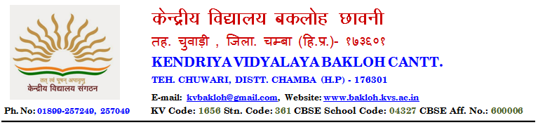
NOTICE
SESSION 2021-22
ADMISSION NOTICE
Class XI(Science and Commerce Stream)
- Registrations open for admission in Class XI.
- Registration Form is available on website as well as in School(during school hours)

Principal
R. N Singh

