dsUnzh; fo|ky; cdyksg Nkouh, rg0- pqokM+h,ftyk–pEck(fg0iz0)- 176301
KENDRIYA VIDYALAYA BAKLOH CANTT.TEH- CHUWARI, DISTT. CHAMBA(H.P)- 176301 Phone No: 01899-257249,257049(FAX), E-mail:kvbakloh@gmail.com,Website: https://bakloh.kvs.ac.in CBSE School Code : 04327 , CBSE Affiliation No.:600006

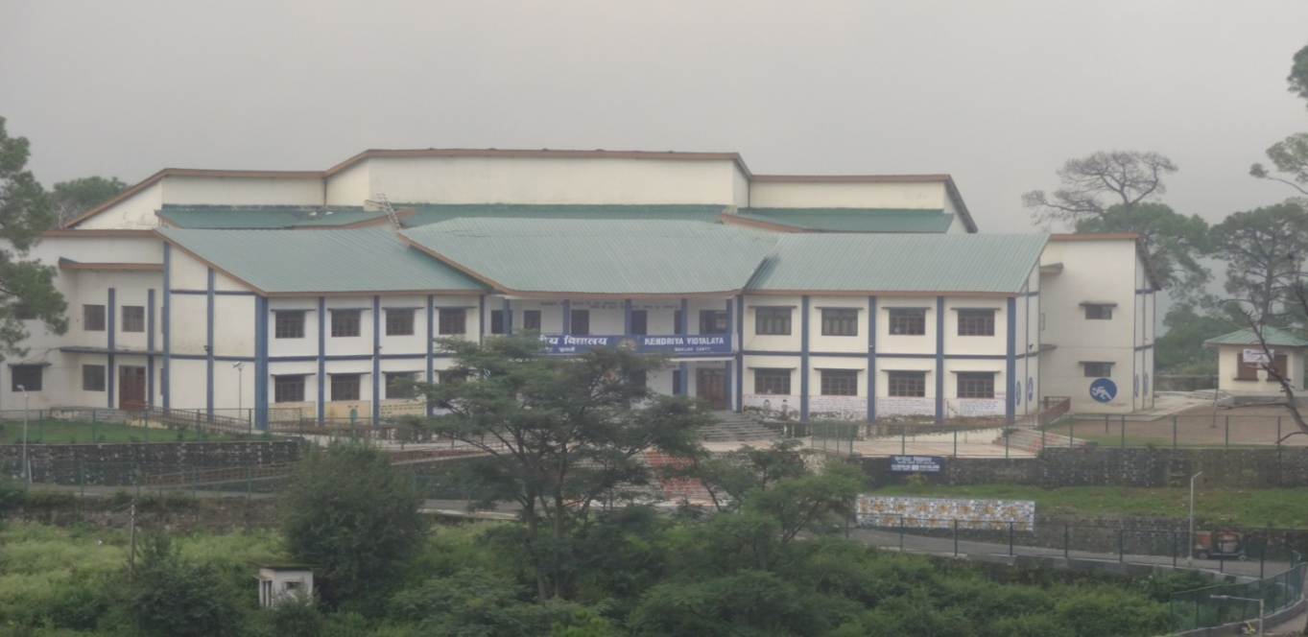
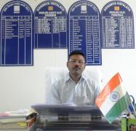
Primary education lays the foundation of the physical, intellectual and emotional growth of the children. Common Minimum Programme enables us to bring qualitative improvement and development in the teaching learning process. Children participate in activities which inculcates an interest toward learning in them. Learning becomes more interesting and joyful for children with the use of ICT. Audio- Visual modules and pictures facilitate effective learning among children. The newsletter is an assemblage of all the activities conducted under CMP.
Principal
R. N . SINGH
ACTIVITIES OF PRIMARY SECTION OF KV BAKLOH

A warm welcome was given to class-I students. All the students of class -I were welcomed by the Principal and all Primary Teachers. All the students are given presents as a token of love from the Vidyalaya.
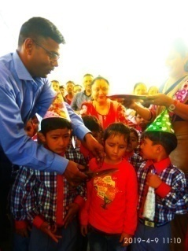
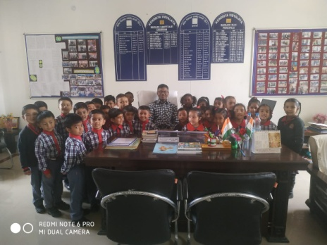
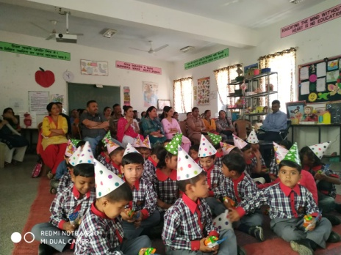

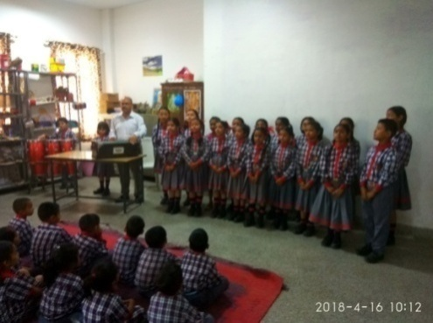
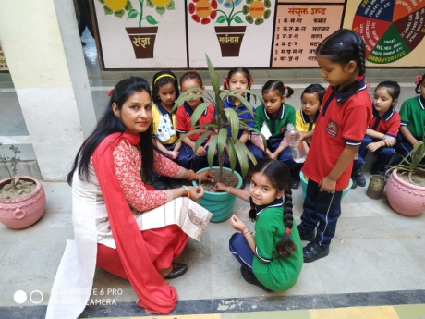
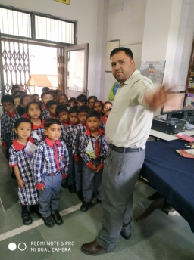

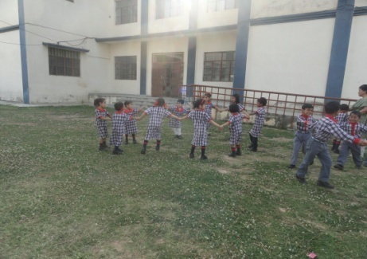
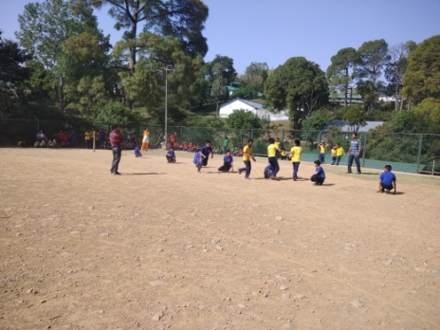
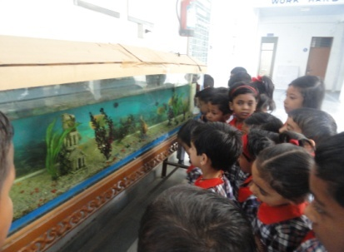
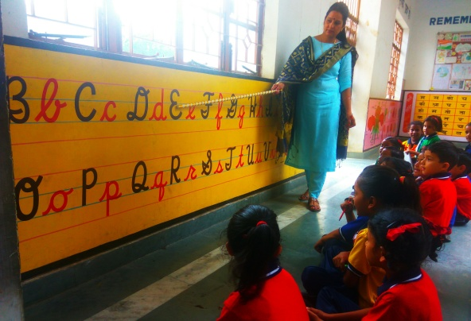
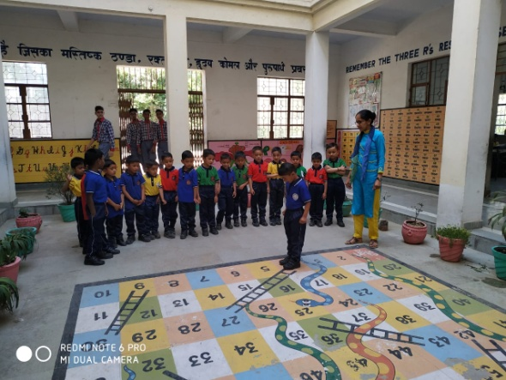
BALA Activities

Creative corner is a wonderful platform for nurturing the talent and developing the scientific temperament of the children.
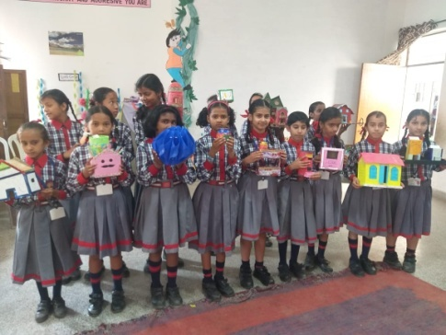
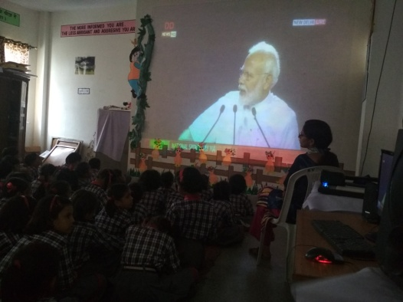
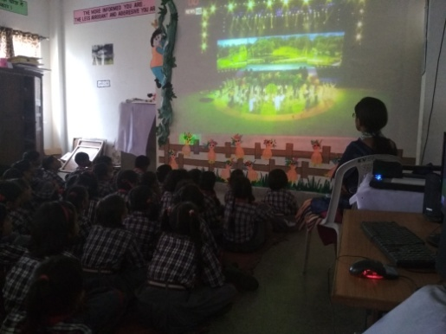

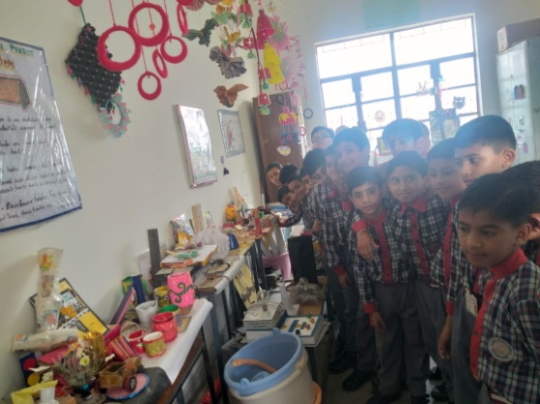
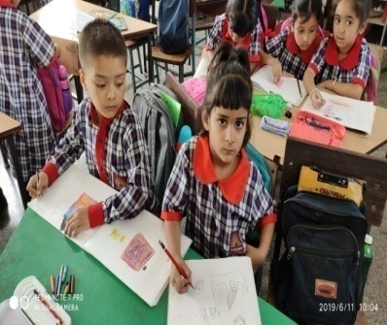
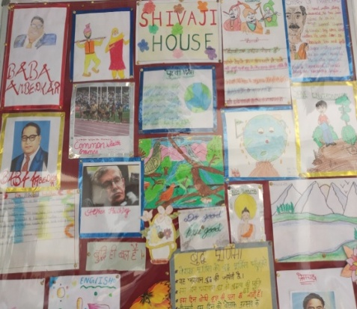

HINDI PAKHWARA & SARAVDHARAM PRATHARNA
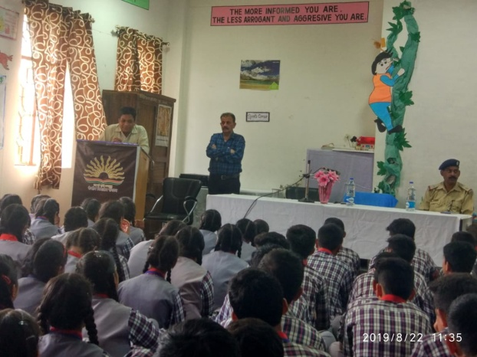
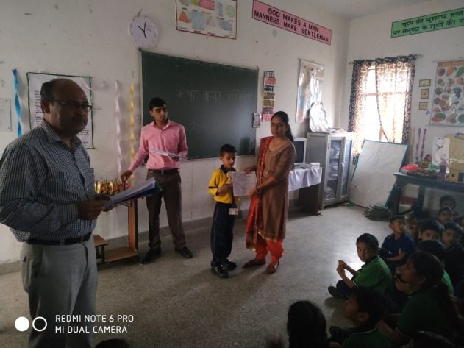
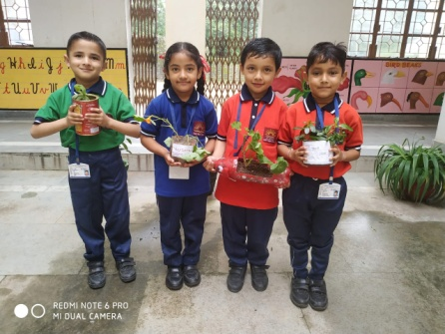

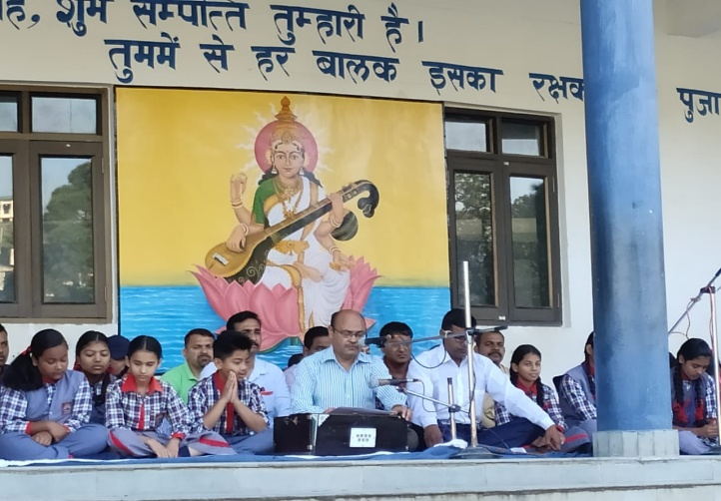
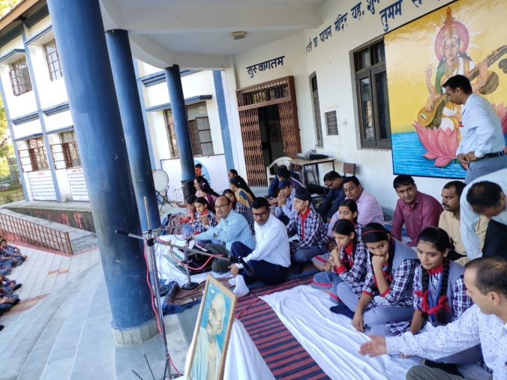

CCA ACTIVITIES

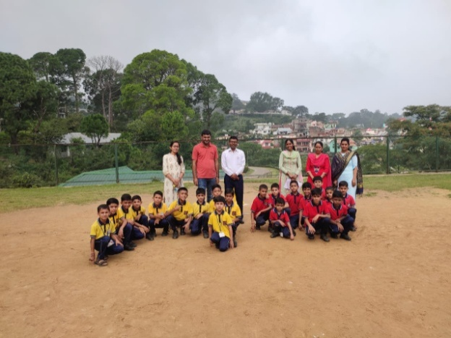
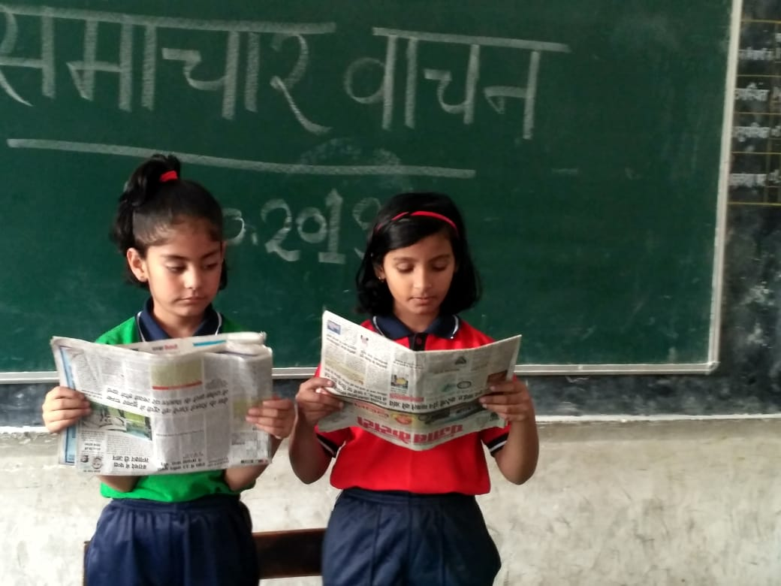

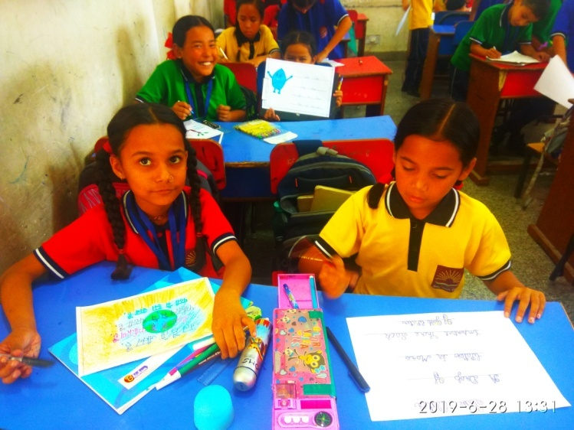

SCOUT AND GUIDE CORNER

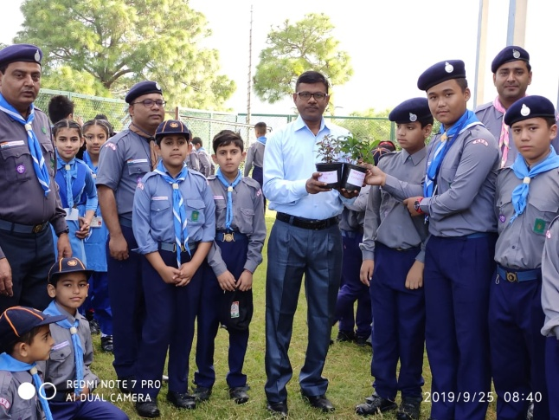
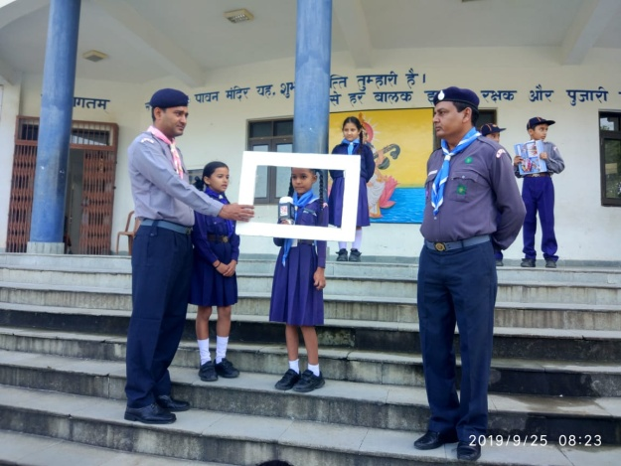
PLANTATION,INDEPENDENCE DAY AND SOLO SONG
