**KENDRIYA VIDYALAYA BAKLOH**

**HOLIDAY HOMEWORK**

**TIME : 90 MIN SUBJECT : PHYSICS MM :40**

1.All questions are compulsory.

2.This question paper has four sections: Section A, Section B, Section C, and Section D.

3.Section A contains five questions of one mark each.

4.Section B contains five questions of two marks each.

5.Section C contains five questions of three marks each.

6.Section D contains two questions of five marks each.

**Section A**

1. Two point charges having equal charges separated by 1m distance experience a force of 8 N. What will be the force experienced by them, if they are held in water at the same distance (k=80).

2. Define SI unit of magnetic field intensity.

3. If = 3 +4-5, calculate the electric flux through a surface of area 50 units in x-y plane.

4. The V-I graph for a conductor makes angle Ѳ with V- axis, what is the resistance of the conductor?’ Write the answer in terms of Ѳ.

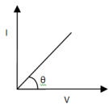

5. A charge q is placed at the centre of a cube of side l . What is the electric flux passing through each face of the cube?

**Section B**

6. The storage battery of a car has an emf of 12 V , If the internal resistance of the battery is 0.4 ohm . What is the maximum current that can be drawn from the battery.

7. In which orientation , a dipole placed in a uniform field is in

(i) stable (ii) unstable equilibrium ?

8 . Three charges –q, Q and –q are placed at equal distances on a straight line. If the potential energy of system of these charges is zero, then what is the ratio of Q:q .

9. Prove that the current density of a metallic conductor is directly proportional to the drift speed of electrons.

10 . A piece of silver wire has a resistance of 1Ω. What will be the resistance of the constantan wire of one third of its length and one half of its diameter if the specific resistance of the constantan wire is 30 times than that of the silver?

**SECTION ‘C’**

11. Define resistivity. Plot a graph showing the variation of resistivity with temperature for a (i) metallic conductor and (ii) semiconductorand give reasons for these variation.

OR

Fig shows two identical capacitors C1  and C2 each of 2µF capacitance , connected to a battery of 5 V . Initially switch S is closed .After sometime S is left open and dielectric slabs of dielectric constant k= 5 are inserted to fill completely the space between the plates of the two capacitors. How will the (i) charge and (ii) Potential difference between the plates of the capacitors be affected after the slabs are inserted?

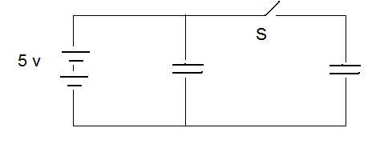

C2=2µf

C1=2µf

12. Define electric dipole moment. Is it a vector or scalar? Derive the expression for the electric field of a dipole at a point on the equatorial plane of the dipole.

13. Net capacitance of three identical capacitors in series is 1μf. What will be their net capacitance if connected in parallel? Find the ratio of energy stored in the two configurations, if they are both connected to the same source

14. Define the term electrostatic potential energy. Find the expression for the electrostatic potential energy of an electric dipole placed in a uniform electric field.

15. State Gauss’s Law and use it to determine the electric field inside, on the surface and outside the surface of a spherical uniformly charged shell .

**Section D**

16. Using Kirchhoff’s laws find the current through each battery in the following network. Also find the potential drop across 12 ohm resistance.

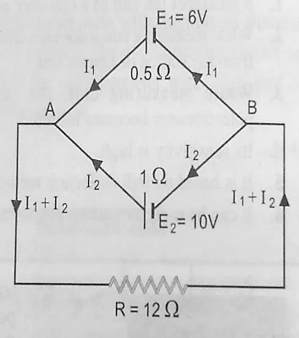

17. Derive the expression for the capacitance of a parallel plate capacitor having a dielectric of thickness t between the plates and also derive the energy stored in parallel plate capacitor when it is charged. Hence obtain the expression for the energy density of the electric field.

# COMPUTER SCIENCE

# Practice questions based on finding error and output.

# Write a program questions in the exercise of chapter 1 & 2.

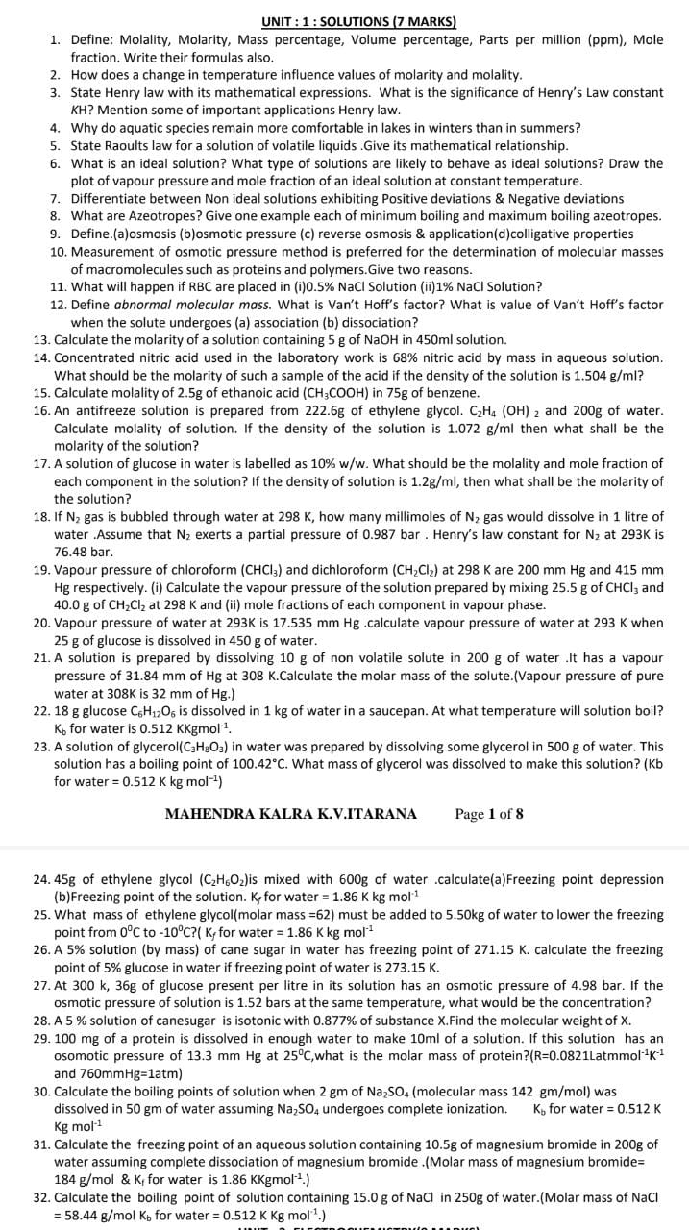

**KENDRIYA VIDYALAYABAKLOH CANTT**

**SUMMER VACATION (2023-24) HOMEWORK**

**CLASS: XII SUBJECT : MATHEMATICS**

**INSTRUCTIONS: Do all these questions in a separate file (A-4 sheets)**

**RELATIONS and FUNCTIONS**

1. Show that the function f: R → R is given by f(x) = x3 is injective.
2. Show that the relation R in the set {1, 2, 3} given by R = {(1, 2), (2, 1)} is symmetric but neither reflexive nor transitive.
3. Check the injectivity of f : R R , f(x) = x3 .
4. Let A = R {3} and B = R – {1}. Consider the function f: A →B defined by f (x) = (x- 2)/(x -3). Is f one-one and onto? Justify your answer.
5. Show that the relation R on A , A = { x ; x ~~Z~~ , 0 ≤ x ≤ 12 } defined as

R = {(a ,b): |a - b| is multiple of 3.}, is an equivalence relation.

1. Show that the modulus function f R -> R, given by f(x) = [x] is neither one-one nor on-to.
2. Prove that R is an equivalence relation,where R:N ×N→N defined as

(a,b) R (c,d) if and only if ad(b+c) = bc(a+d).

1. Let N be the set of natural numbers and R be the relation in NX N defined by (a,b) R (c,d) if and only if a+d=b+c. Show that R is an equivalence relation.

**INVERSE TRIGONOMETRIC FUNCTIONS**

1. Find the principal value of the following:
   1. 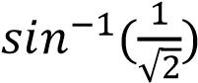 b) 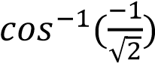 c) 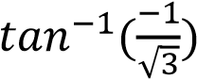 d)  e) 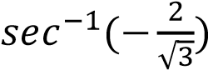
2. Find the value of the following:
   1. 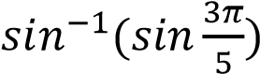 b) 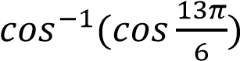 c) 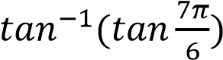 d) 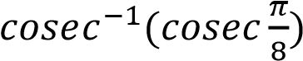
3. Evaluate the following:

a) 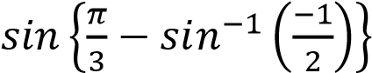 b) 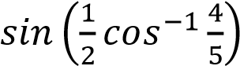 c) 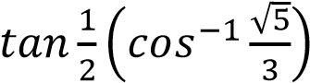.

1. Evaluate:. 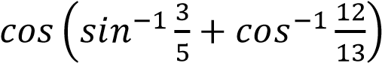

**MATRICES and DETERMINANTS**

1. If A and B are symmetric matrices of the same order, then prove that   
    AB + BA is a symmetric matrix
2. If A is a square matrix, then Prove that A – A’ is a skew-symmetric matrix

3) Construct 23 matrix A = [a ij] whose elements a ij is given by a ij =

4) Find X and Y if 2 X + Y =, X - 2Y= 

5) Find x and y if A = so that A2 – x A + y I = 0 hence find inverse of A .

6 ) Express the matrix as sum of symmetric and skew-symmetric matrices 

8 ) The sum of three numbers is 6. If 3rd number is multiplied by 2 and first number is added, we get 7 and by adding second and third number to 3 times the first number we get 12. Use matrix method to find the numbers.

9) If, find k such that.

10) Express A as a sum of symmetric and a skew symmetric matrix. A =

11) Use the product A= to solve the system of equations

x-y+2z = 1, 2y – 3z= 1, 3x-2y+4z = 2

12) Solve for x : =0

13) Let A =en show that A2-4A+7I=O and also calculate A5.

14) Find the matrix X such that

विषय - हिंदी

1.पठित पाठ (भक्तिन, आत्मपरिचय, सिल्वर वैडिंग) के आधार पर 10 अति लघु उत्तरीय प्रश्न बनाएं और उनके उत्तर लिखें।

2.अनुच्छेद लिखिए –(i) आज़ादी का अमृत महोत्सव, (ii) मेरी प्रिय यात्रा।

3. अभिव्यक्ति और माध्यम - पाठ संख्या 3 पढ़ें और पाठ से 5 अति लघु उत्तरीय प्रश्न बनाकर उनके उत्तर लिखें।

ENGLISH

Holiday Homework

15 very short answer type questions from The Third Level

15 very short answer type questions from My mother at Sixty six and Keeping Quiet..

3 Report Writing in about 220 to 250 words with situations to write on note books

# BIOLOGY

# CHAPTERS INCLUDED:

* SEXUAL REPRODUCTION IN FLOWERING PLANT
* HUMAN REPRODUCTION
* REPRODUCTIVE HEALTH

# COMPETENCIES AIMED:

* COMPREHENSION
* ANALYTICAL SKILL AND REASONING
* DRAWING SKILL
* CRITICAL THINKING
* OBSERVATION AND PROCESS THINKING

## ‘DIAGRAM’ BASED QUESTIONS

Q1.Draw a diagrammatic sectional view of a mature anatropous ovule and label the following:

1. That develops into seed coat
2. That develops into embryo after fertilisation
3. That develops into endosperm in an albuminous seed
4. Through which pollen tube gains entry into the embryo sac
5. That attaches the ovule to placenta

Q2. Draw a sectional view of seminiferous tubule of a human. Label the following cells in the seminiferous tubule:

1. Cells that divide by mitosis to increase their number
2. Cells that undergo meiosis I
3. Cells that undergo meiosis II
4. Cells that help in the process of spermiogenesis.

Q3. Draw the following diagrams related to human reproduction and label them:

1. The zygote after first cleavage
2. Morula stage
3. Blastocyst stage (sectional view)

## ‘FLOW CHART’ BASED QUESTIONS

Q4. Prepare a flow chart of the steps that would follow to ensure that seeds are formed only from the desired sets of pollen grains. Name the process.

Q5. Give a flow chart showing hormonal role in spermatogenesis.

Q6. Study the flow chart given below. Name the hormones involved at each stage and explain their functions

Hypothalamus----- pituitary------ Ovary Pregnancy

## ‘DIFFERENCE’ BASED QUESTION

Q7. Write the differences in tabular form:

1. Megasporogenesis and microsporogenesis
2. Wind pollinated flowers and insect pollinated flower( based upon stigma. Pollen, colour of flower, fragrance and nectar)
3. False fruit ,true fruit, parthenocarpic fruit
4. Perisperm and endosperm
5. Apomixis and parthenocarpy
6. Spermatogenesis and oogenesis (based upon time of initiation, site of completion and nature of meiotic division.
7. Spermatogenesis and spermiogenesis
8. GIFT and ZIFT
9. IUT and IUI
10. ICSI and Artificial insemination
11. Oral pills and surgical methods( based upon advantages and disadvantages)

## ‘WHY’ BASED QUESTIONS

Q8. Why do corn cob has long tassels?

Q9 Even though each pollen grain has two male gametes, why are at least 10 pollen grains and not 5 pollen grains required to fertilise 10 ovules present in a particular carpel?

Q10 Why is parturition called a neuro- endocrine mechanism? Q11 Why is menstrual cycles absent during pregnancy?

Q12. Why is early detection of STD essential? What can it lead to?

## ‘HOW’ BASED QUESTIONS

Q13. How do the pollen grains of *Vallisneria* protect themselves? Q14. How does a bisexual flowering plant ensure cross pollination?

Q15 How is entry of only one sperm and not many, ensured into an ovum during fertilisation in humans?

Q16. How is placenta formed in the human female? Q17 How does ‘CuT’ act as an effective contraceptive?

*******************************